
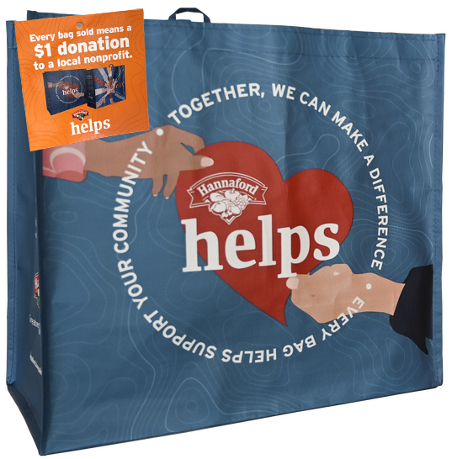
COMMUNITY BAG PROGRAM

Announcement Email

& Social Post

SUBJECT LINE: We’ve been selected to partner with the Hannaford Community Bag Program!

PREVIEW TEXT: During [Month], we receive $1 for every reusable Community Bag purchased at our selected Hannaford location!

Dear [Staff/Board/Volunteers/Supporters],

We are excited to share that Hannaford has selected [organization] to benefit from the Community Bag Program throughout [month]. The Hannaford Community Bag Program makes it easy for shoppers to contribute to their local communities.

Every time a $2.50 reusable Community Bag is purchased at the Hannaford located at [location] in [month], $1 will be donated to [organization]. This is a great way to broaden awareness of our mission and help our cause.

Let’s get started! Share the news with friends and family. Call, send emails, and post on social media. The more people who purchase a Community Bag in [month], the greater the donation we will receive from Hannaford!

For more information about this program, please visit hannaford.2givelocal.com.
Best,
[Signature]





Share With Your Followers

We’re excited that Hannaford has selected our organization to benefit from the Community Bag Program! Throughout [month], we will receive a $1 donation for every $2.50 reusable Community Bag purchased at the Hannaford located at [address of selected store(s)].

