
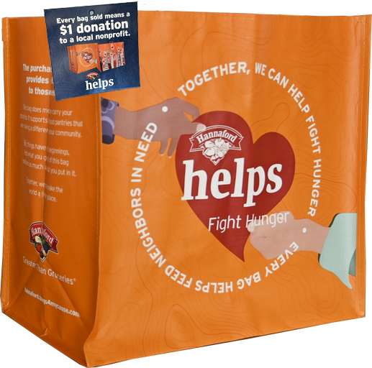
HANNAFORD FIGHT HUNGER BAG PROGRAM

Fact Sheet

Congratulations on your organization’s selection in the Hannaford Fight Hunger Bag Program! The Fight Hunger Bag is a component of the Hannaford Helps Reusable Bag Program together with the Community Bag.

Not sure how to start talking about the program? We’re here to help! We’ve brought together key facts and talking points from across the program website compiled in one place. Below you will find information you can use to discuss this program with your board, staff, and supporters:
- The Hannaford Helps Reusable Bag Program has been operating since April 2014 when the first Fight Hunger Bag was sold. The first Community Bag was sold in October 2015.
- Since inception, the program has donated $3,590,373 to 6,517 nonprofit organizations and sold 4,257,419 reusable bags.*
- Hannaford operates 219 stores across Maine, Massachusetts, New Hampshire, Vermont and New York that participate in the program.
- The Hannaford Fight Hunger Bag Program makes it easy for shoppers to support their communities and environment by buying durable, reusable shopping bags. A portion of each purchase goes to a local hunger relief organization.
- Every month, the Store Leadership Team at each Hannaford location chooses a local hunger relief organization to be the monthlong beneficiary of the Fight Hunger Bag. Different nonprofits are selected every month to ensure the many organizations making a difference in our local communities can be supported by this program. The name of the organization is displayed on the reusable bag rack during their benefiting month.
- Generally, the nonprofits selected by a specific store are within a 10-mile radius of that store location. It’s important to note that this program benefits each store’s regional shopping area.
________________________________________
*As of 5.12.25. These statistics are updated regularly on the program website and can be found here. You will want to use the most recent stats available at the time of your selection.

Page 2

- Each bag costs $2.50, with $1 of that purchase going to support a benefiting nonprofit in your community.
- Nonprofits meeting the program's qualifications are submitted to our database of thoroughly researched organizations within the vicinity of each store location
- A list of nonprofit organizations that have benefited from the Fight Hunger Bag Program can be found here on the program website and is organized alphabetically.
- The bags are made from 95% recycled materials from either nonwoven or woven polypropylene. They are manufactured in Vietnam in factories that follow the strictest guidelines for employment and production standards.
Published xx

