
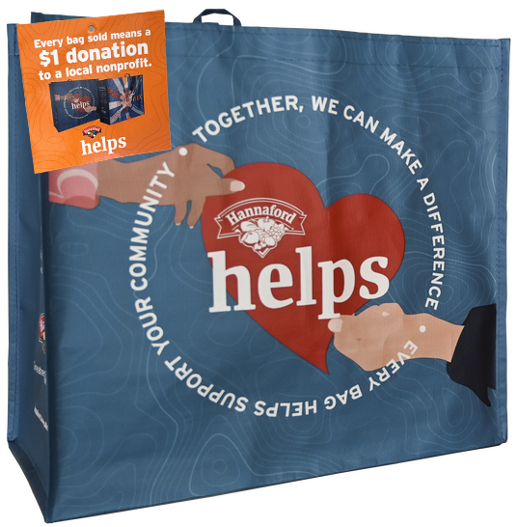

COMMUNITY BAG PROGRAM

Reminder Email

SUBJECT: We have [insert number of weeks or other time frame] weeks remaining in our Hannaford Community Bag Program partnership!

PREVIEW TEXT: There’s still time to maximize this opportunity for our cause!

Good morning,
We've reached [or We will shortly reach] the halfway point in our [insert month] partnership with the Hannaford Community Bag Program. This is a wonderful opportunity to raise funds for our organization and to spark positive change in our community!
Remember, for every $2.50 reusable Hannaford Community Bag purchased at [insert location(s)] this month, we'll receive $1. Every bag counts, so let's maximize this opportunity!
Please spread the word to your friends and family. Let's encourage everyone to look for the Hannaford Community Bags in our selected store(s) this month. There’s still time left to make a difference!
For more information about this impactful program, please visit hannaford.2givelocal.com.
Thank you for your support!
Best,
[Signature]

